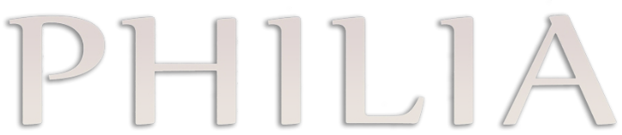
INTERNATIONAL JOURNAL OF ANCIENT MEDITERRANEAN STUDIES
ASSIGNMENT of COPYRIGHT FORM
Title of Article :
Author(s) (as given in the submitted article):
AUTHOR’S CONTACT INFORMATION
Name & Surname (Title) :
Address :
Date : | Mobile :
E-mail : | Fax :
DECLARATION of CONSENT
I consent to publish my article mentioned below in the journal named «PHILIA: International Journal of Ancient Mediterranean Studies» (ISSN 2149-505X), which will be printed by Phoibos Publisher.
I, the author of the article submitted undersigned, accept and agree that:
a) PHILIA has whole publishing right and copyright of the article in print both now and in the future;
b) the article is an original submission, complying with the publication ethics and the malpractice statement, and has not been published or submitted for publication elsewhere;
c) all of the information, tables, diagrams, etc., are rightfully documented and recorded;
d) PHILIA and its editors cannot be held responsible. In the case of any legal dispute regarding copyright and permissions concerning the contents of the published article. All legal responsibility remains with the author(s) of the article;
e) the author(s) are not entitled to reuse and share the published article in their own books, teachings, conference proceedings, presentations, or any online platforms.
f) all printing and distribution rights belong to Phoibos Publisher and I will claim no payment for the article I’ve written.

Nationality :
ID Number :
Name & Surname :
Signature : | Date : …/…/202..

The assignment of copyright form must be signed by all authors of the article. Each author should sign and send the form separately, and all authors’ forms must be received prior to publication of the article. All wet-ink signatures must be hand written, and a written, PDF copy of this form must be sent to the journal via e-mail prior to publication. All documents and versions of unpublished article(s) will not be returned, but are retained for a year following publication, after which they are destroyed.

